Design Document
Table of Contents
- System Overview
- Implementation Details
- Use Case Support in Design
- Design Decisions

Writers
- Tenay Giray
- İpek Atak
- Defne Saracel
- Nehir Adak

- System Overview
Brief Project Description:
In this project we are aiming to raise environmental awareness with our mobile platform “Planeta”. Planeta is a mobile platform that tracks individuals’ daily activities with daily surveys. It provides appropriate feedback according to their answers and score. It helps users to see their progress with weekly/monthly reviews that encourage them to be more consistent with their act.

To keep users’ enthusiasm alive, beside score ranking system it also awards users with badges at milestones. Planeta offers simple user interface with dark/light mode switch option and daily enlightening quotes about nature.
It promotes sustainable use of natural resources in an interesting way.

System Architecture:
Planeta designed to follow a client-server model where the Flutter application acts as the client and Firebase acts as the server (BaaS). This serverless approach enables system to handle authentication and data storage in a simple way. The application is structured using a layered architecture that consists of 3 layers.
- Presentation Layer:
The user interacts with application through this layer. We decided to use Flutter to build our user interface. This layer handles UI, mode switching and local state management. It provides authentication services by using “Firebase Auth”.
- Service Layer:
This layer is the brain of the application; it acts like a bridge between presentation and database layer. It handles raw data to transform into meaningful results. This layer is responsible for score calculation, choosing accurate feedback according to result, controlling milestones and rank situations, business logic validation and so on.

- Database Layer:
For database layer we use “Cloud Firestore” a NoSQL document database. It helps system to store user profiles, daily survey results, earned badges and ranks while enabling real time updates. Service layer process the data fetched from Firestore which resides here.

Component Diagram:
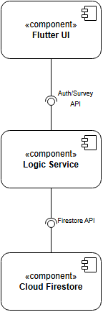

Deployment Diagram:
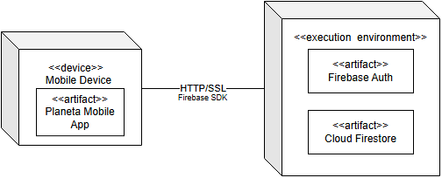

Technology Stack:
- Frontend Framework: Flutter
- Authentication System: Firebase Auth
- Backend / Database: Cloud Firestore
- State Management: Provider (Flutter Library)
- Design: Flutter (Material Design 3)
- Deployment: Android (APK) / IOS

- Implementation Details
- Use Case Support in Design
- Design Decisions

Task Matrix

- Tenay Giray | - System Overview
- İpek Atak | - Use Case Support in Design
- Defne Saracel | - Implementation Details, Design Decisions
- Nehir Adak | - Implementation Details, Design Decisions

